

Quarterly Crime Statistics
Q2 2012
(01-April-2012 to 30-June-2012)

Authorising Officer: Commissioner Of The Bermuda Police Service
Author: Analysis Unit
Date: 13-JUL-2012
File Location: G:Intelligence Briefings\Intelligence Analysts\2012\Statistics\Q2 2012\ Q2 2012 BPS Statistics
Security Classification: This document is marked as UNCLASSIFIED. Further dissemination is allowed internally and externally of the BPS, without further authorisation.

INDEX

1. INTRODUCTION Page 2

2. ALL CRIME Page 4

3. CRIMES AGAINST THE PERSON Page 5

4. FIREARM INCIDENTS Page 6

5. CRIMES AGAINST THE COMMUNITY Page 8

6. CRIMES AGAINST PROPERTY Page 9

7. TRAFFIC COLLISIONS Page 10

8. DRUG ENFORCEMENT ACTIVITY Page 11

9. TRAFFIC ENFORCEMENT ACTIVITY Page 13

10. INCIDENTS - CALLS FOR SERVICE Page 14

11. ARRESTS - ALL OFFENCES Page 15

12. STOP AND SEARCHES Page 18

Appendix A - Crime Statistics In Bermuda (Q1 2008 – Q2 2012)

Appendix B - Enforcement Activity In Bermuda (Q1 2008 – Q2 2012)

Appendix C – Traffic Collision Statistics In Bermuda (Q1 2008 – Q2 2012)

Appendix D - Chart Of All Crime In Bermuda By Quarter (Q1 2000 – Q2 2012)

1. INTRODUCTION

1.1 SECURITY CLASSIFICATION
This document is marked as UNCLASSIFIED as there are no sensitive details contained in it and it is expressly written to be circulated both internally and externally.

1.2 DATA INTEGRITY
The statistics, tables and graphs contained in this document are based on substantiated cases, which are active investigations of an incident that has definitely happened. This is as opposed to using incident data, which is an initial recording of a crime that has yet to be substantiated.

While every effort is made to ensure that the information contained in this report is accurate, the BPS makes no warranty, representation or guarantee as to the content, sequence, accuracy, timeliness or completeness of any data or information provided. The reader of the following pages should not rely on the data provided for comparison purposes over time, or for any reason. The BPS shall assume no liability for any errors, omissions, or inaccuracies in the information provided. The BPS will not be responsible for the use of, or the results obtained from the use of this document. The BPS assumes no liability for any decisions made or actions taken or not taken by the user in reliance of this document. Any use of the document for commercial purposes is prohibited.

1.3 EXPLANATION OF GRAPHS
The graphs used in this report include standard deviation, which has been used as a means of objectively measuring how much the crime rate has varied over time and is useful in identifying extreme highs and lows of crime. Standard deviation has been used so that where the crime rate is above the red line (2 standard deviation above the mean average), it is considered exceptionally high. Where the crime rate is below the blue line (2 standard deviation below the mean average), it is considered exceptionally low. In both cases it can be referred to as statistically significant (high or low) and is an indication of whether the quarterly statistics are exceptionally high or exceptionally low.

1.4 AIM
The aim of this report is to produce accurate, timely, objective information that:
- Enables informed decisions to be made on the types of crime that threaten the safety of the community.
- Is used to proactively manage risks to the island and ensure effective policing, redeploying and directing resources at a strategic and tactical level, as required.
- Facilitates effective and open communication with our stakeholders, developing the means to inform them of the plans, efforts and progress being made by the BPS.
- Provides meaningful information as one of the means of reassuring communities in Bermuda.

1.5 Executive Summary
There were 1,038 offences in Q2 2012, a decrease of -10.7% when compared to Q1 2012. All Crime in Q2 2012 is the 3rd lowest quarterly figure since 2000. Of note, Arrests and Incidents – Calls for Service in Q2 2012 were at their lowest since Q1 2009. Stop and Searches in Q2 2012 were also at their lowest since Q3 2009.

There was 1 murder and 1 injury by firearms in Q2 2012.

Crimes Against The Community have increased when Q2 2012 is compared to Q1 2012. Crimes Against The Person and Crimes Against The Property have decreased when Q2 2012 is compared to Q1 2012. A summary of the 3 key crime headings and 20 crime categories for Q2 2012 in comparison to the previous quarter (Q1 2012), the same quarter last year (Q2 2011) and the 5 year trend is shown below in figure 1:

Figure 1: Summary Of All Crime (Q2 2012)

CRIME CATEGORY | Q2 2012 vs. Q1 2012 | Q2 2012 vs. Q2 2011 | 5 year Trend
CRIMES AGAINST THE PERSON
Murder
Manslaughter
Serious Assaults
Other Assaults
Sexual Assault
Robbery
Offences Against Children
Indecency
CRIMES AGAINST PROPERTY
Burglary (Residential)
Burglary (Non Residential)
Burglary (Tourist Accommodation)
Criminal Damage
Motor Vehicle Theft
Theft of Property
Fraud and Deception
CRIMES AGAINST THE COMMUNITY
Firearm Offences
Other Weapon Offences
Disorder Offences
Anti-Social Behaviour
Animal Offences
GRAND TOTAL (ALL CRIME)
Remains level
Decreasing
Increasing
LEGEND:

2. ALL CRIME

2.1 SUMMARY
The total for all crime in Q2 2012 decreased by -125 offences or -10.7% compared to Q1 2012. In comparison to the same period last year (Q2 2011), Q2 2012 has decreased by -101 offences or by -8.9%. The total for Q2 2012 was 1,038 as can be seen in Figure 2:

Figure 2: All Crime (Last 5 Quarter comparison Q2 2011 – Q2 2012)

 | 2011 | 2011 | 2011 | 2012 | 2012 | Percentage Change | Absolute Change
 | Q2 | Q3 | Q4 | Q1 | Q2 | Percentage Change | Absolute Change
ALL CRIME | 1139 | 1076 | 1165 | 1163 | 1038 | -10.7% | -125

2.2 TRENDS
Q2 2012 is the 3rd lowest quarterly crime figure since Q1 2000. In 2008 and 2009, all quarters were above 1,200 offences. Since 2010, only two quarters have been above 1,200 offences. This reinforces the view that there has been a decrease in the long term trend of all crime in Bermuda. This can be seen in Figure 3, which shows crime for the last 18 quarters, with Q2 figures highlighted in boxes:

Figure 3: All Crime By Quarters (Q1 2008 – Q2 2012)

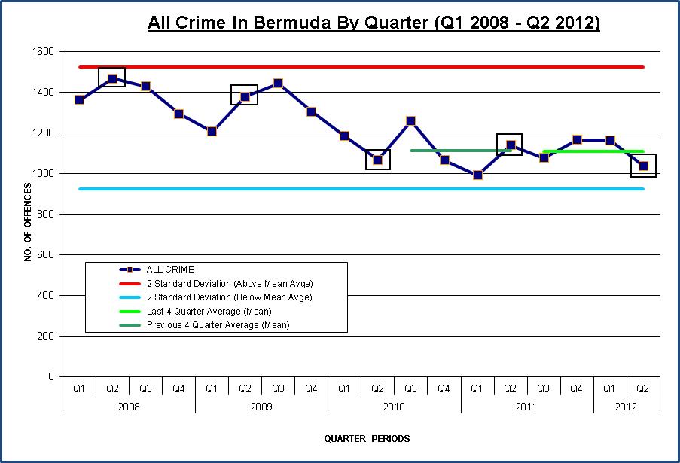
3. CRIMES AGAINST THE PERSON

3.1 SUMMARY
Crimes Against the Person offences in Q2 2012 decreased by -16 offences or -8.6% compared to Q1 2012. In comparison to the same period last year (Q2 2011), Q2 2012 has decreased by -26 offences or by -13.3%. The total for Q2 2012 was 170 as can be seen in Figure 4:

Figure 4: Crimes Against the Person (Last 5 Quarter comparison Q2 2011 – Q2 2012)

 | 2011 | 2011 | 2011 | 2012 | 2012 | Percentage Change | Absolute Change
 | Q2 | Q3 | Q4 | Q1 | Q2 | Percentage Change | Absolute Change
C.A.T.P. | 196 | 163 | 184 | 186 | 170 | -8.6% | -16

3.2. TRENDS
In Q2 2012 the long term trend of Crimes Against The Person is decreasing with Q2 2012 the 8th consecutive quarter under 200 offences. When compared to Q1 2012, the notable crimes of Q2 2012 within the Crimes Against A Person category were Serious Assaults (-7) and Other Assaults (-5). Sexual Assaults have increased (+5) when compared to Q1 2012. A summary of Crimes Against The Person for the last 18 quarters can be seen in Figure 5, with Q2 figures highlighted in boxes:

Figure 5: Crimes Against the Person By Quarters (Q1 2008 – Q2 2012)

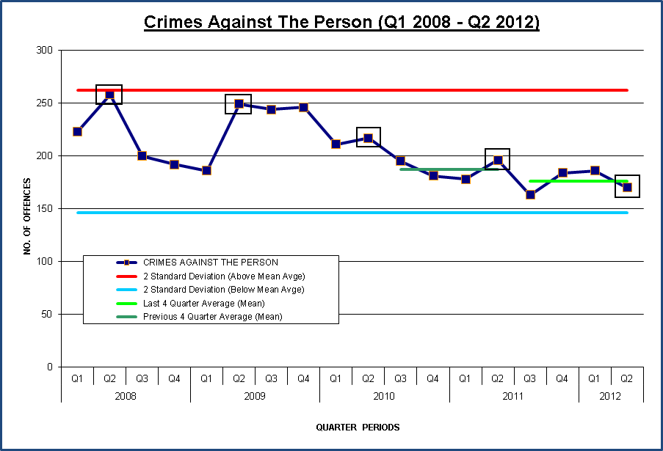

4. FIREARM INCIDENTS
Firearm Offences are included within Crimes Against The Community (Section 5); however firearm incidents may not necessarily be recorded as offences, as often there is no suspect or even a victim.

4.1 SUMMARY
In Q2 2012 there were 9 firearm incidents of which 4 were Confirmed Firearm Incidents and 5 were Recovery Of A Firearm and or Ammunition. This is a decrease from the 17 firearm incidents in Q1 2012. This can be seen in Figure 6 below, which shows firearm incidents between 2009 and 2012:

Figure 6: Firearm Incidents In Bermuda (2009 - 2012)

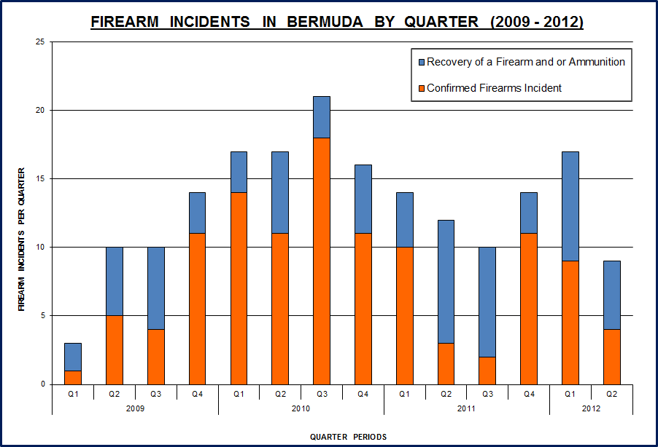

4.2 FIREARM TRENDS
In Q2 2012, there were 5 firearms and/or ammunition recovered, 1 fatality and 1 injury. This brings the total number of persons shot since the dramatic increase of firearm incidents in Q1 2009 to 74, of which 18 have been fatal shootings. Figure 7 (below) shows firearm fatalities and injuries from Q1 2009 to Q2 2012:

Figure 7: Firearm Injuries and Fatalities In Bermuda (Q1 2009 – Q2 2012)

5. CRIMES AGAINST THE COMMUNITY

5.1 SUMMARY
Crimes Against The Community offences in Q2 2012 increased by +8 offences or +4.2% compared to Q1 2012. In comparison to the same period last year (Q2 2011), Q2 2012 has decreased by -27 offences or by -11.9%. The total for Q2 2012 was 200 as can be seen in Figure 8:

Figure 8: Crimes Against The Community (Last 5 Quarters Q2 2011 – Q2 2012)

 | 2011 | 2011 | 2011 | 2012 | 2012 | Percentage Change | Absolute Change
 | Q2 | Q3 | Q4 | Q1 | Q2 | Percentage Change | Absolute Change
C.A.T.C. | 227 | 204 | 170 | 192 | 200 | 4.2% | 8

5.2 TRENDS
Q2 2012 is lower than Q2 2011 and there has been a decrease since Q2 2010. When compared to Q1 2012, Crimes Against The Community have increased in Q2 2012, especially Anti-Social Behaviour (+14). A summary of Crimes Against The Community for the last 18 quarters can be seen in Figure 9, with Q2 figures highlighted in boxes:

Figure 9: Crimes Against The Community By Quarters (Q1 2008 – Q2 2012)

6. CRIMES AGAINST PROPERTY

6.1. SUMMARY
Crimes Against Property offences in Q2 2012 decreased by -117 offences or -14.9% compared to Q1 2012. In comparison to the same period last year (Q2 2011), Q2 2012 has decreased by -48 offences or by -6.7%. The total for Q2 2012 was 668 as can be seen in Figure 10:

Figure 10: Crimes Against Property (Last 5 Quarter comparison Q2 2011 – Q2 2012)

 | 2011 | 2011 | 2011 | 2012 | 2012 | Percentage Change | Absolute Change
 | Q2 | Q3 | Q4 | Q1 | Q2 | Percentage Change | Absolute Change
C.A.P. | 716 | 709 | 811 | 785 | 668 | -14.9% | -117

6.2 TRENDS
The long term trend of Crimes Against Property is down; offences have decreased from 716 in Q2 2011 to 668 in Q2 2012. Burglary (Residential) has decreased from 237 offences in Q1 2012 to 183 offences in Q2 2012, however Burglary (Tourist Accommodation) has increased from 1 offence in Q1 2012 to 7 offences in Q2 2012. A summary of Crimes Against Property for the last 18 quarters can be seen in Figure 11, with Q2 figures highlighted in boxes:

Figure 11: Crimes Against Property By Quarters (Q1 2008 – Q2 2012)

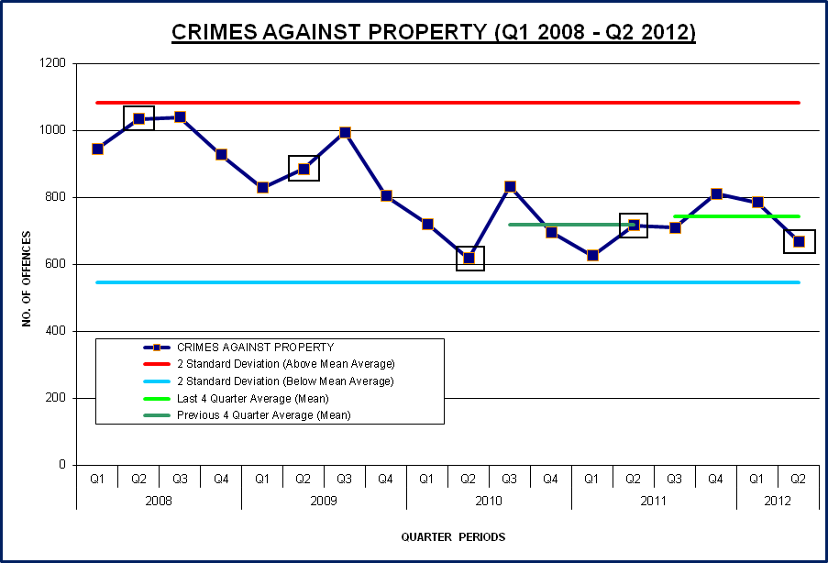

7. TRAFFIC COLLISIONS

7.1 SUMMARY
Traffic Collisions in Q2 2012 increased by 44 or +9.9% compared to Q1 2012. In comparison to the same period last year (Q2 2011), Q2 2012 has decreased by -72 or -12.9%. The total for Q2 2012 was 488 as can be seen below in Figure 12:

Figure 12: Traffic Collisions (Last 5 Quarter comparison Q2 2011 – Q2 2012)

 | 2011 | 2011 | 2011 | 2012 | 2012 | Percentage Change | Absolute Change
 | Q2 | Q3 | Q4 | Q1 | Q2 | Percentage Change | Absolute Change
TRAFFIC COLLISIONS | 560 | 497 | 468 | 444 | 488 | 9.9% | 44

7.2 TRENDS
The long term trend of Traffic Collisions continues to decrease. From over 600 per quarter in 2008, Traffic Collisions have decreased and the last 4 quarter running average was 474. One of the most important categories of Traffic Collisions is fatalities and these have continued to decrease, with only 1 in Q2 2012. There was an increase in slight injury collisions compared to Q1 2012, but a decrease compared to Q2 2011. A summary of Traffic Collisions for the last 18 quarters can be seen in Figure 13, with Q2 figures highlighted in boxes:

Figure 13: Traffic Collisions (Q1 2008 – Q2 2012)

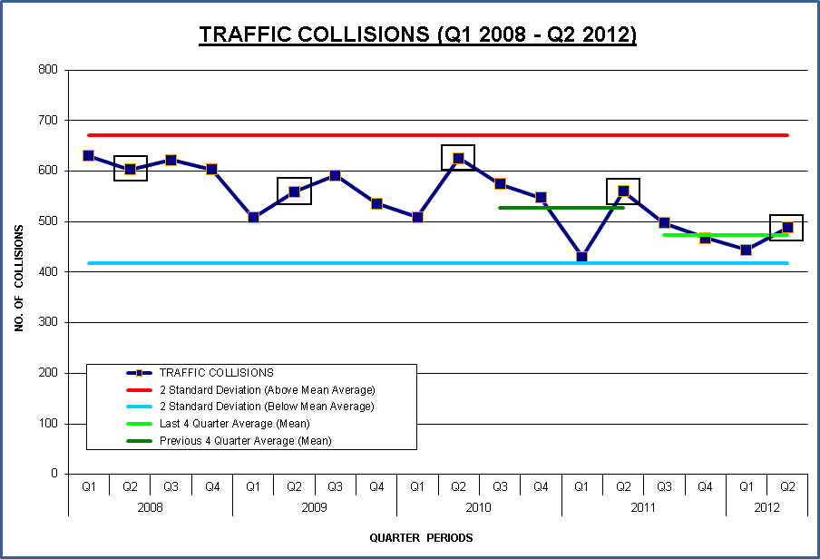
8. DRUG ENFORCEMENT ACTIVITY
Drug Enforcement Activity refers to policing activity against drugs seized at the border, or activity that has led to arrests or seizures in Bermuda.

8.1 SUMMARY
Drug Enforcement Activity in Q2 2012 increased by +16 or +11.0% compared to Q1 2012. In comparison to the same period last year (Q2 2011), Q2 2012 has decreased by -98 offences or -37.8%. The total for Q2 2012 was 161 as can be seen in Figure 14:

Figure 14: Drug Enforcement Activity (Last 5 Quarter comparison Q2 2011 – Q2 2012)

 | 2011 | 2011 | 2011 | 2012 | 2012 | Percentage Change | Absolute Change
 | Q2 | Q3 | Q4 | Q1 | Q2 | Percentage Change | Absolute Change
DRUG ENFORCEMENT ACTIVITY | 259 | 223 | 179 | 145 | 161 | 11.0% | 16

8.2 TRENDS
Drug Enforcement Activity has increased in Q2 2012 when compared to Q1 2012, and the value of drugs seized has also increased. A summary of Drug Enforcement Activity for the last 18 quarters can be seen in Figure 15, with Q2 figures highlighted in boxes:

Figure 15: Drug Enforcement Activity By Quarters (Q1 2008 – Q2 2012)

8.3 Drug Seizures
The Bermuda Police Service continues to work with its partners both locally and overseas to disrupt the trafficking of controlled drugs. These partners include HM Customs Bermuda, U.S. Customs and the U.S. Drug Enforcement Administration. Despite these partnerships, controlled drugs are still entering Bermuda which is evidenced in the number of ‘street’ level drug seizures. This can be seen in Figure 16, which shows Drug Seizures By Location:

Figure 16: Drug Seizures In Bermuda By Location (Q2 2012)

Location | Number Of Seizures
PORT | 51
STREET | 107
OVERSEAS | 3

As can be seen in Figure 16, the majority of drugs seized are at street level (107) while there were 51 seizures at ports (including LF Wade) and 3 overseas seizures which involved overseas law enforcement agencies.

An estimated total of 49.6 Kg of controlled drugs with an estimated street value of $3.2 million has been seized in Q2 2012, with Cannabis the most common drug with 44 Kg seized at a value of $2.2 million. Cocaine is the next highest, with 3.9 Kg seized with a value of $0.9 million. The type, weight and value of the drugs seized broken down by Port, Street and Overseas seizures can be seen below in Figure 17:

Figure 17: Drug Seizures by Location, Weight and Street Value (Q2 2012)

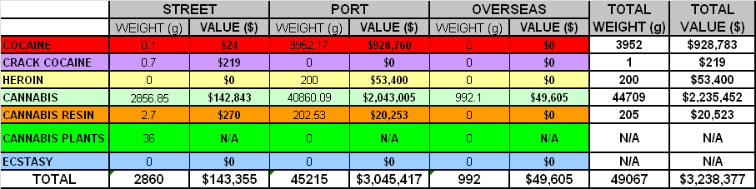
(All weights are in grams)

In comparison to Q1 2012, the value of drugs seized in Q2 2012 has increased, with an estimated street value of $3.2 million compared to $1.9 million. This is due to the increase in seizures of Cocaine at port level and Cannabis at street and port level.

9. TRAFFIC ENFORCEMENT ACTIVITY

9.1 SUMMARY
Traffic Enforcement Activity in Q1 2012 decreased by -1,546 or -16.8% compared to Q1 2012. In comparison to the same period last year (Q2 2011), Q2 2012 has decreased by -3,474 or -31.2%. The total for Q1 2012 was 7,660 as shown below in Figure 18:

Figure 18: Traffic Enforcement Activity (Last 5 Quarter comparison Q2 2011 – Q2 2012)

 | 2011 | 2011 | 2011 | 2012 | 2012 | Percentage Change | Absolute Change
 | Q 2 | Q 3 | Q 4 | Q 1 | Q 2 | Percentage Change | Absolute Change
T.E.A. | 11134 | 9413 | 8444 | 9206 | 7660 | -16.8% | -1546

9.2 TRENDS
Traffic Enforcement Activity has fluctuated between a low of 8,951 in Q2 2008 to a high of 16,342 in Q4 2009. With 7,660 in Q2 2012, Traffic Enforcement Activity is decreasing. A summary of Traffic Enforcement Activity for the last 18 quarters can be seen in Figure 19, with Q2 figures highlighted in boxes:

Figure 19: Traffic Enforcement Activity By Quarters (Q1 2008 – Q2 2012)

10. INCIDENTS - CALLS FOR SERVICE

10.1 SUMMARY
Incidents refer to all police activity and also to calls for service that have been recorded on the police computer system (New World System). Incidents in Q2 2012 decreased by -1,676 or -16.2% compared to Q1 2012. In comparison to the same period last year (Q2 2011), Q2 2012 has decreased by -2,780 or -24.2%. The total for Q2 2012 was 8,692 as shown in Figure 20:

Figure 20: Incidents - (Last 5 Quarter comparison Q2 2011 – Q2 2012)

 | 2011 | 2011 | 2011 | 2012 | 2012 | Percentage Change | Absolute Change
 | Q 2 | Q 3 | Q 4 | Q 1 | Q 2 | Percentage Change | Absolute Change
INCIDENTS | 11472 | 10455 | 10122 | 10368 | 8692 | -16.2% | -1676

10.2 TRENDS
Q2 2012 saw a decrease in incidents being recorded in comparison to Q1 2012. There were 8 consecutive quarters of more than 10,000 incidents being recorded from Q2 2010 to Q1 2012. The large decrease in Q2 2012 is therefore noticeable in comparison to recent quarters. This can be seen in Figure 21, which shows incidents for the last 18 quarters, with Q2 figures highlighted in boxes:

Figure 21: Incidents By Quarters (Q1 2008 – Q2 2012)

11. ARRESTS - ALL OFFENCES

11.1 SUMMARY
Arrests refer to those persons arrested and brought into police custody. Arrests in Q2 2012 decreased by -4 or -0.5% compared to Q1 2012. In comparison to the same period last year (Q2 2011), Q2 2012 has decreased by -509 or -38.2%. The total for Q2 2012 was 825 as shown in Figure 22:

Figure 22: Arrests - All Offences (Last 5 Quarter comparison Q2 2011 – Q2 2012)

 | 2011 | 2011 | 2011 | 2012 | 2012 | Percentage Change | Absolute Change
 | Q 2 | Q 3 | Q 4 | Q 1 | Q 2 | Percentage Change | Absolute Change
ARRESTS | 1334 | 1033 | 896 | 829 | 825 | -0.5% | -4

11.2 TRENDS
Q2 2012 represents a large decrease in the number of persons arrested and is one of the lowest quarterly figures since Q1 2008. A summary of arrests for the last 18 quarters can be seen in Figure 23, with Q2 figures highlighted in boxes:

Figure 23: Arrests By Quarters (Q1 2008 – Q2 2012)

11.3 GENDER
Of the 825 persons arrested in Q2 2012, 687 were male and 138 were female.

11.4 AGE
Analysis of persons arrested by age revealed that individuals from 26 to 35 years of age were arrested more frequently than any other age group (246), followed closely by those aged 18 to 25 (215). A breakdown of persons arrested by their age group can be seen below in Figure 24:

Figure 24: Arrests By Age Group (Q2 2012)

Breakdown by age
Below 18 years | 72
18 - 25 years | 215
26 - 35 years | 246
36 - 45 years | 141
46 - 55 years | 103
56 - 65 years | 41
66 + years | 7

11.5 NATIONALITY
Of the 825 persons arrested in Q2 2012 742 were Bermudian and 83 were foreign nationals. This is similar to previous quarters.

11.6 ETHNICITY
The majority of individuals arrested were black (714), with 83 individuals being white. In addition, 4 of those arrested was Asian, 3 individuals fall into the category ‘black and white’, 1 individual was classified as ‘black and other’ and 20 individuals fall into the category ‘other’. This is also similar to arrest figures in previous quarters. A breakdown of persons arrested by their ethnicity can be seen below in Figure 25:

Figure 25: Arrests - Ethnic Origin (Q2 2012)

ETHNICITY
Black | 714
White | 83
Asian | 4
Black & White | 3
Black & Other | 1
White & Other | 0
Other | 20
11.7 TYPE OF ARREST
Of the 825 persons arrested in Q2 2012, the most common category was ‘all other offences’ which includes HMC, apprehension, SJA and civil warrants with 255. There were 5 arrests for murder and 5 arrests for firearm offences in Q2 2012. A breakdown of the offences persons were arrested for can be seen overleaf in Figure 26:
Figure 26: Arrests - Offence Type (Q2 2012)

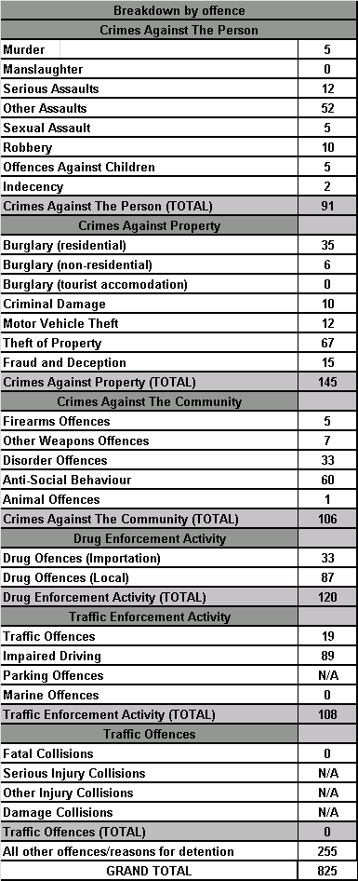

11.8 RECIDIVISM
Of the 825 persons arrested in Q2 2012, 61 individuals were arrested more than once and accounted for 131 of the arrests for this period.

12. STOP AND SEARCHES

12.1 SUMMARY
Stop and Searches are conducted in a proportionate and accountable manner and only when Police Officers have occasion to exercise lawful powers. They are carried out with courtesy, consideration and respect for the individual being stopped. While the figures are not performance indicators, they are a reflection of the frequency of engagement between proactive Police Officers and Prolific Priority Offenders. They provide an indication of police activity, particularly regarding the number of highly visible patrols in the community.

There were 1,127 Stop and Searches in Q2 2012, a decrease of -833 or -42.5% compared to Q1 2012. In comparison to Q2 2011, Q2 2012 has decreased by -5,314 or -82.5%. This can be seen in Figure 28, showing Stop & Searches for the last 14 quarters, with Q2 figures highlighted in boxes:

Figure 28: Stop & Searches By Quarter (Q1 2009 – Q2 2012)

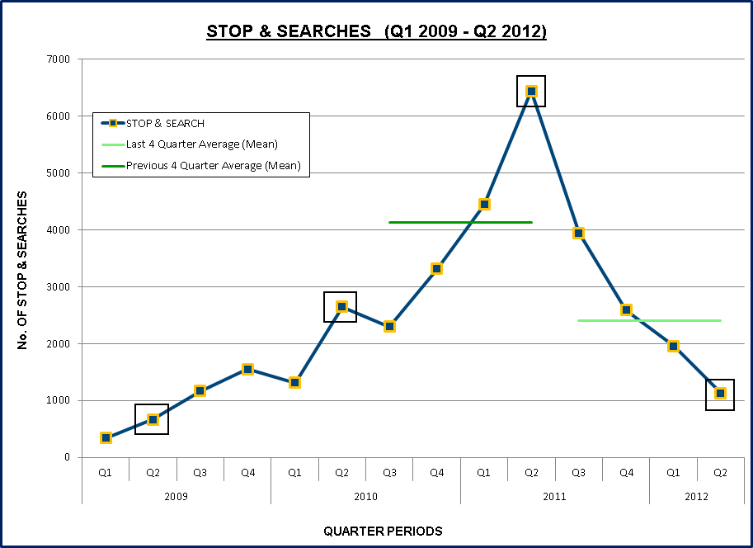
Appendix A - Crime Statistics In Bermuda (Q1 2008 – Q2 2012)

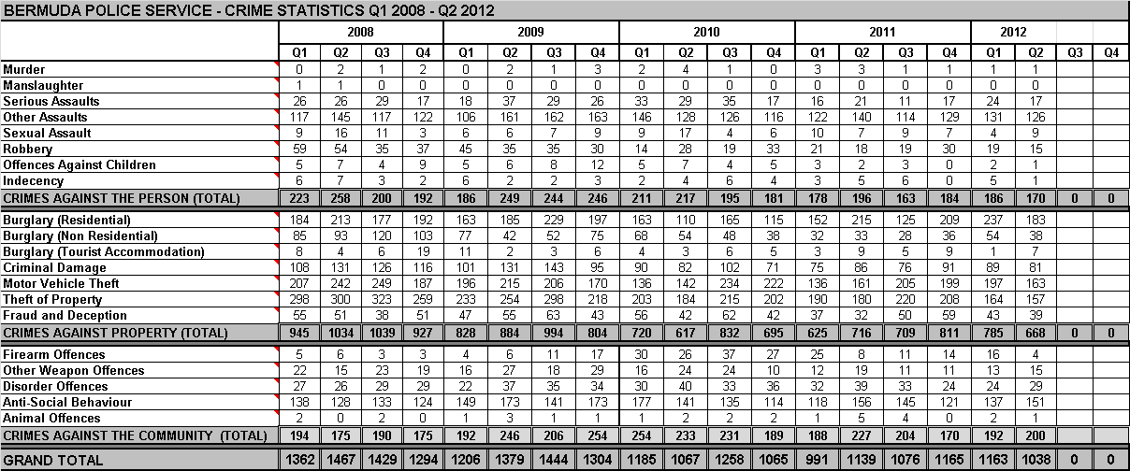

Appendix B - Enforcement Activity Statistics In Bermuda (Q1 2008 – Q2 2012)

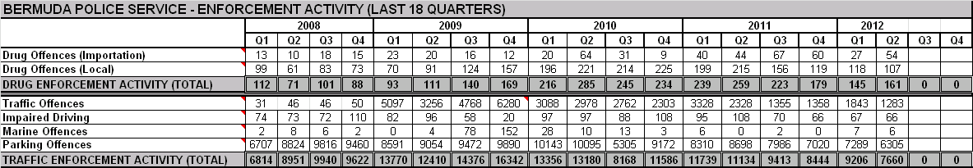

Appendix C - Traffic Collision Statistics In Bermuda (Q1 2008 – Q2 2012)

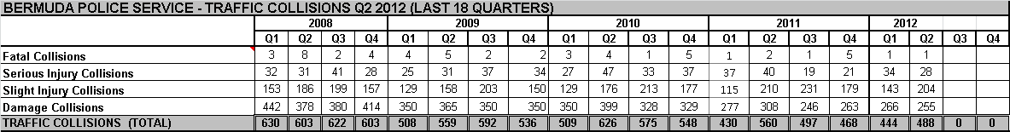

Appendix D - Chart Of All Crime In Bermuda By Quarter (Q1 2000 – Q2 2012)

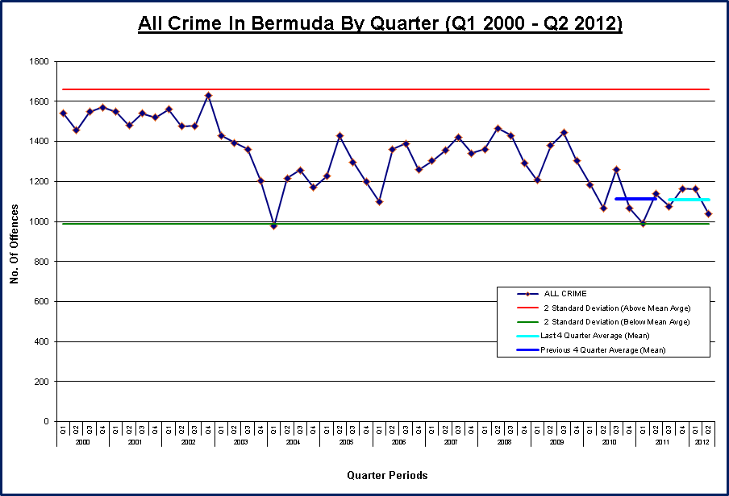

See Appendix D for a chart showing All Crime In Bermuda By Quarter (Q1 2000 – Q2 2012).
To enable accurate recording, analysis and reporting of firearm incidents, the BPS classifies firearm incidents into 2 categories which are split into Confirmed or Recovery Of A Firearm and Or Ammunition. An Confirmed incident is where a person has been shot (fatally or wounded), a person has been shot at and corroboration is provided by forensic recovery of ballistic material, CCTV footage showing a firearm, reliable witness testimony or a person is charged with a firearms offence connected to the incident, a firearm is used in the commission of a criminal act and corroboration has been obtained, or a report of a firearm discharged and forensic material (bullet casings) have been recovered. A Recovery Of A Firearm and Or Ammunition is where a firearm, ammunition or imitation firearm is recovered by police.
Traffic Collisions include fatal, serious injury, slight injury and damage only collisions.

